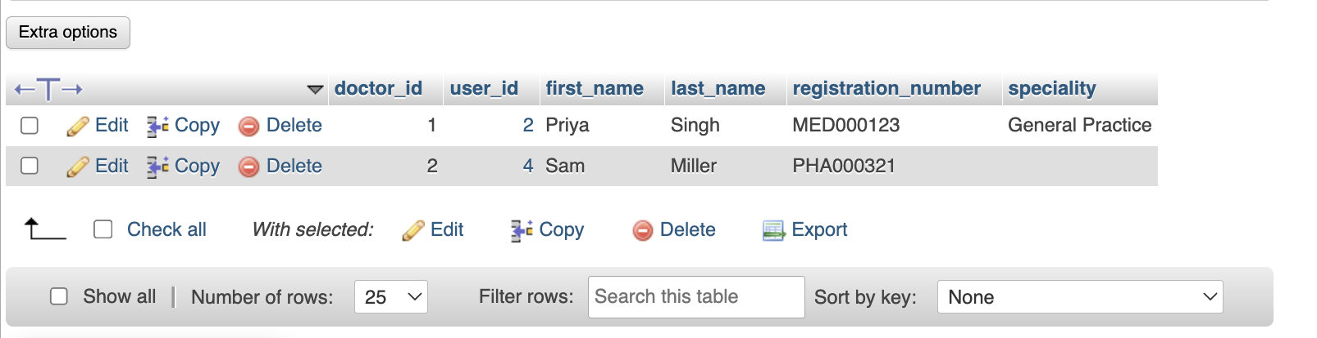
Stores doctor profile and professional identification information linked to the central user account. Each doctor record contains doctor_id, user_id, first_name, last_name, registration_number, and speciality. The visible entries include Priya Singh in General Practice and Sam Miller with a professional registration number. Keeping these fields separate from the users table allows authentication details to remain centralized while doctor-specific names, registration credentials, and clinical speciality are maintained in a dedicated profile.

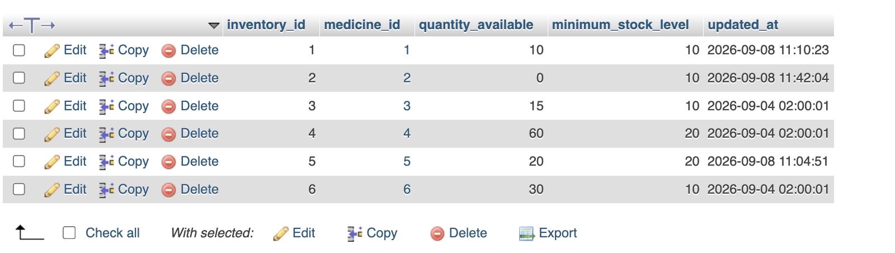
Maintains the central medicine inventory totals. Each inventory_id is linked to a medicine_id and records quantity_available, minimum_stock_level, and updated_at. The sample rows show different stock positions, including medicine 2 with zero units against a minimum level of 10 and other medicines at or above their thresholds. This gives the system a simple overall stock view and provides the values needed to identify low-stock or out-of-stock medicines.

Maintains detailed authenticated login sessions. Each login_session_id belongs to a user_id and stores a session_token_hash, role_name, ip_address, user_agent, login_at, last_activity_at, expires_at, logout_at, status, remember_me flag, and audit timestamps. The visible session is for a Patient role and is already Expired. Hashing the session token rather than storing the raw token supports safer session validation while the timestamps and client information allow session lifecycle and security activity to be tracked.

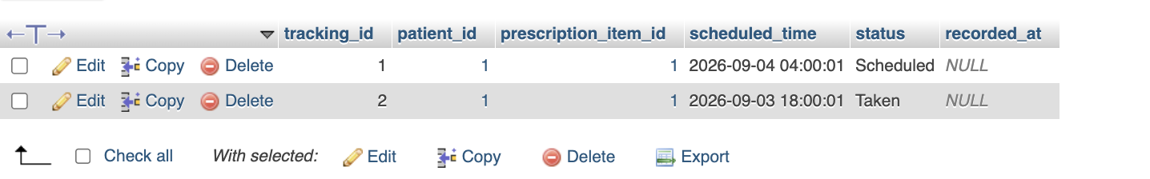
Tracks medication adherence against individual prescription items. Each tracking_id connects a patient_id to a prescription_item_id and records the scheduled_time, status, and recorded_at value. The sample records show one dose still Scheduled and another marked Taken. This structure allows the application to build a time-based medication schedule for a patient and retain the status of each planned dose, which can then be used for reminders or adherence history.

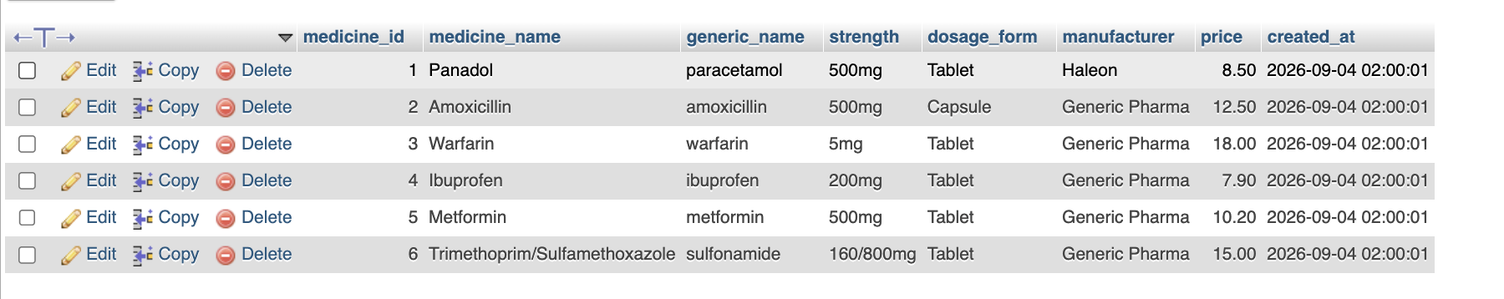
Serves as the master medicine catalogue. Each medicine_id stores a medicine_name, generic_name, strength, dosage_form, manufacturer, price, and created_at timestamp. The supplied records include Panadol/paracetamol, Amoxicillin/amoxicillin, Warfarin, Ibuprofen, Metformin, and Trimethoprim/Sulfamethoxazole. Centralizing these identifiers and product attributes gives prescriptions, inventory, batches, interaction checks, and shortage records a consistent medicine reference.

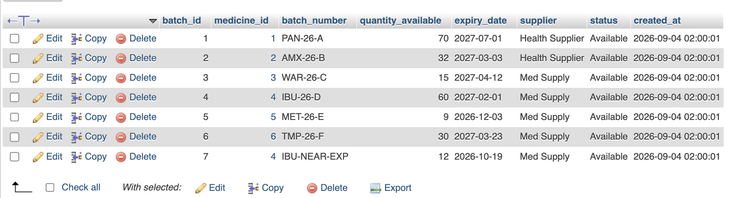
Provides batch-level medicine stock and expiry information. Every batch_id is tied to a medicine_id and contains a batch_number, quantity_available, expiry_date, supplier, status, and created_at. The visible batches are marked Available and include an Ibuprofen batch labelled IBU-NEAR-EXP with an earlier expiry date than the other stock. This structure supports lot traceability, supplier identification, expiry monitoring, and selection of an appropriate batch when medicine is dispensed.

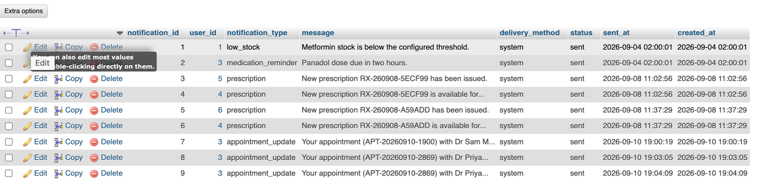
Stores system notifications sent to users. Each notification_id links to a user_id and classifies the message through notification_type, while message contains the notification text, delivery_method records how it was delivered, and status, sent_at, and created_at record its delivery state and timing. The visible examples include low-stock, medication-reminder, new-prescription, and appointment-update notifications, showing that the table supports both clinical and operational communications.

